<https://www.metinfo.cn/download/>

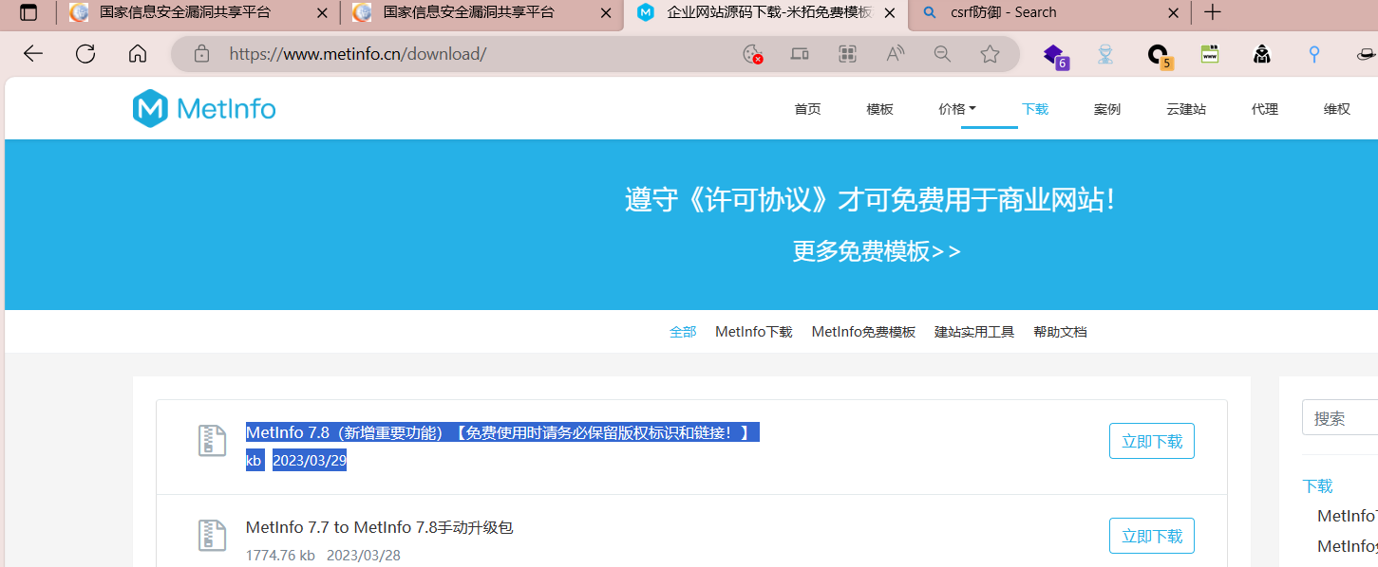

MetInfo7.8\app\system\user\admin\admin_group.class.php In doDelUser(), there was no judgment on whether the operation was authorized or not, only deletion was made,

Causing the deletion of any ordinary member/agent user in CSRF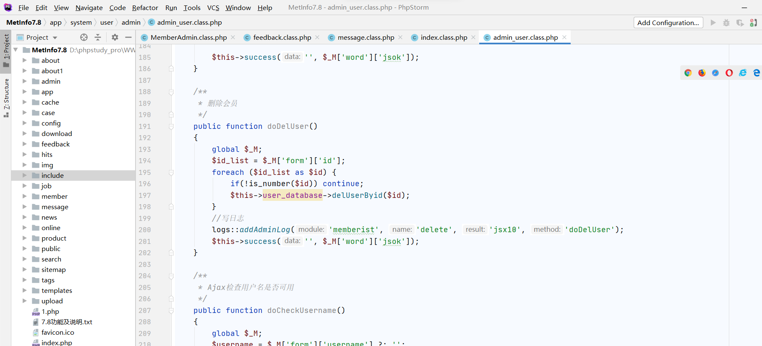

Test1 id =8

Test2 id=9

Click to delete the packet capture (the first packet) and send it to BP's csrf generation module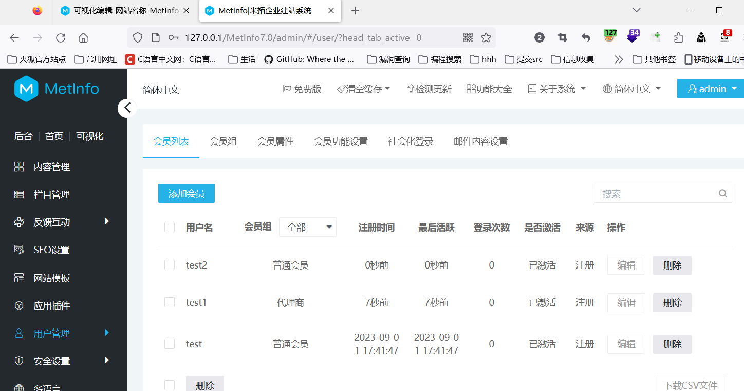

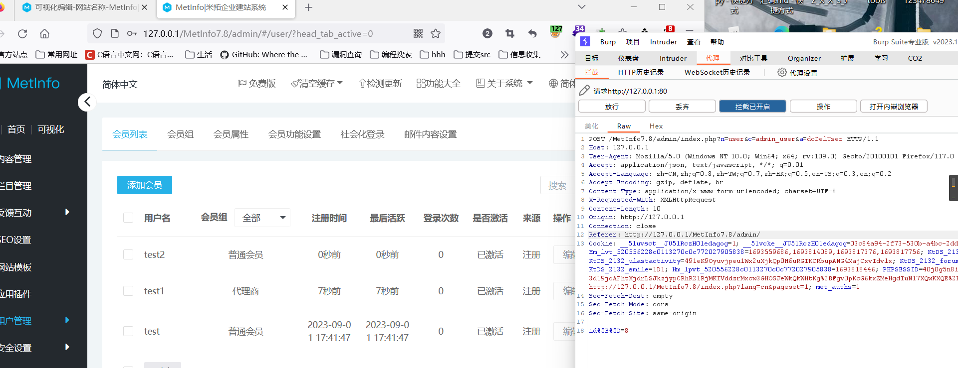

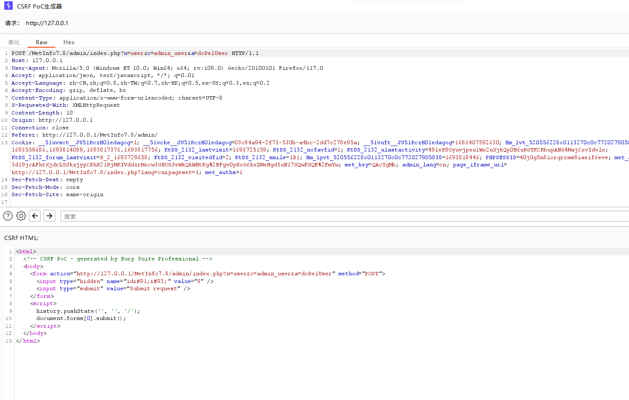

Change Id to ID 9 of test2

Change your browser to access 192.168.190.217/csrf.html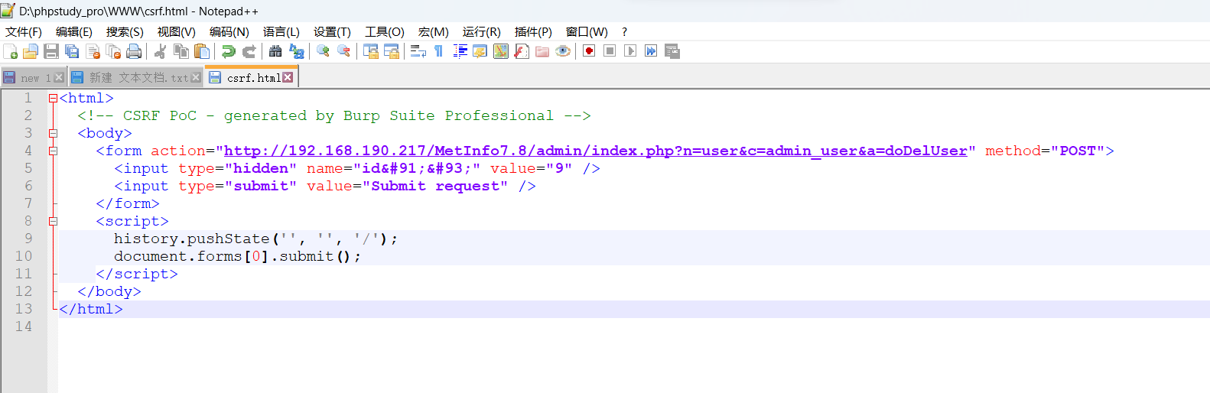



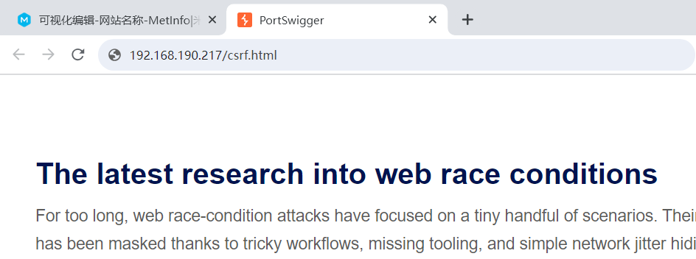

Successfully deleted

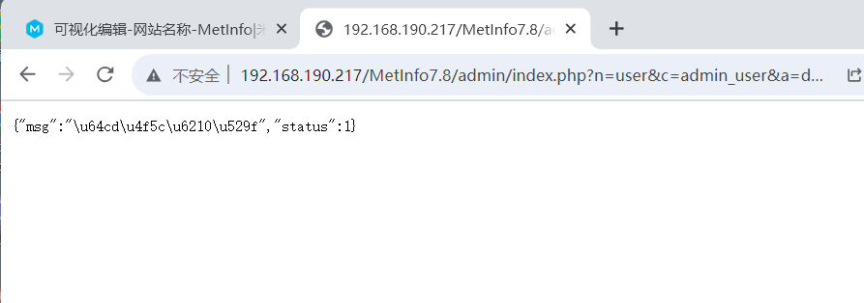

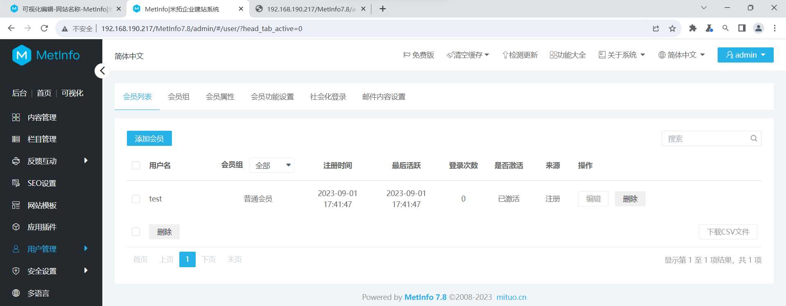

Test2 successfully deleted